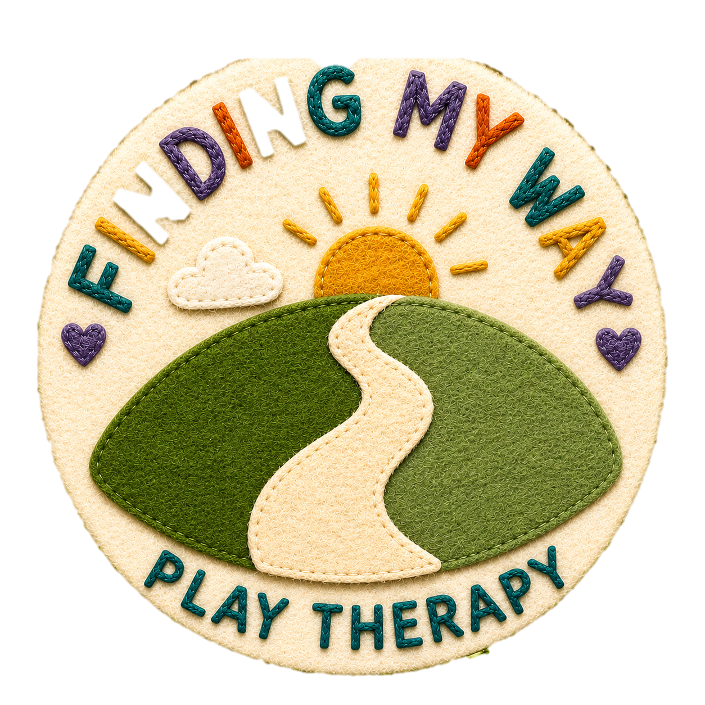
Therapeutic Contract for Play Therapy

Welcome
Welcome to Finding My Way Play Therapy. This agreement explains how play therapy works, what you can expect from me as your child's therapist, and what I ask of you to help therapy be as effective as possible. Please read it carefully and ask if anything is unclear.
My name is Tessa Cope, Certified Play Therapist and a registered member of Play Therapy UK (PTUK), accredited by the Professional Standards Authority (PSA).
PTUK Membership Number: __________
My work is guided by the PTUK Ethical Framework and Code of Professional Practice.
Play Therapy

Following the Initial Parent Assessment, we have agreed to begin play therapy for ________________________. Therapy will begin with an Introductory (Family) Session on ________________, followed by a minimum of 12 weekly play therapy sessions scheduled during term time. Whilst the minimum number of sessions is 12, around 18 sessions are generally recommended to allow sufficient time for the therapeutic relationship to develop and for meaningful therapeutic work to take place. However, every child is different, and the number of sessions will be reviewed according to your child's individual needs.

Children often communicate thoughts and feelings more naturally through play than through words. Play therapy provides a safe, accepting and confidential space where children can explore their emotions, relationships and experiences at their own pace. I work using an Integrative Holistic Play Therapy approach. This means your child is free to express themselves through play, art, creativity, sand, stories, sensory materials and other therapeutic resources. Sessions are primarily child-led, although I may introduce more structured therapeutic activities where appropriate.

Introductory (Family) Session
The Introductory (Family) Session gives your child the opportunity to meet me, become familiar with the playroom and explore the play materials. During this session, I will explain what play therapy is in an age-appropriate way and answer any questions your child may have.
Parents or carers are welcome to attend this first session if they feel it will help their child settle. Some children feel more comfortable with a parent present initially, while others are happier to attend independently. We can discuss what is likely to work best for your child during the Initial Parent Assessment.
Following the introductory session, play therapy sessions are attended by the therapist and child only. If your child finds separating from you difficult, we will work together to find the most supportive approach. This may involve a gradual transition over the first few sessions if needed.
Play therapy should always feel like your child's choice. While parents make the decision to seek support, therapy is most effective when a child feels safe, respected and free to choose whether to enter the playroom and engage in the therapeutic process. I will never force a child to participate. Instead, I will work at your child's pace, building trust and helping them feel comfortable enough to attend willingly.

Therapy Sessions
Each play therapy session lasts approximately 40 minutes and takes place in the Play Therapy Room at: Bath Area Play Project. Sessions take place on the same day and time each week wherever possible.
Children who have experienced significant trauma may require additional sessions, as developing a trusting therapeutic relationship can take longer. If I feel your child would benefit from continuing therapy beyond the planned sessions, this will be discussed during a Parent Review Meeting.
Ending therapy is an important part of the therapeutic process. Wherever possible, therapy should finish gradually over at least three planned sessions to provide your child with a positive ending. If therapy needs to finish earlier than expected, I ask that your child attends a final goodbye session.
The dates of our sessions are listed below so do please let me know as soon as possible if any of these dates are inconvenient.

Therapy Schedule:
Session | Date | Time | Venue
Introductory (Family) Session
Session 1
Session 2
Session 3
Session 4
Session 5
Session 6
Session 7
Session 8
Session 9
Session 10
Session 11
Session 12

Bath Area Play Project address: Odd Down Community Centre. Odins Road. Odd Down. Bath. BA2 2TL

Parent Reviews
Parent Reviews are an important part of the therapeutic process and provide an opportunity for us to reflect on your child's progress together. A review meeting will usually take place around Session 7, with a further meeting at the end of your child's therapy. These meetings are charged separately.
During the review, we will discuss how your child is presenting at home, any significant changes you have noticed since therapy began, and the general themes emerging through the therapeutic process. We will also reflect on the hopes and goals identified during the Initial Parent Assessment and consider whether any further sessions or additional support may be beneficial.
Parents and carers are welcome to contact me by email at any point during therapy if they wish to share significant changes or events in their child's life. This information can be helpful in supporting your child and informing the therapeutic process.

Arriving and Collecting Your Child
Access to the playroom is normally through the side entrance of Odd Down Community Centre (basketball court side). I will meet you and your child at the entrance before each session and accompany your child to the playroom.
During the session, parents or carers are asked to remain nearby, preferably in their car, with their phone switched on in case they need to be contacted.

At the end of each session, I will bring your child back to the agreed collection point. Please refer to the Play Therapy Room Risk Assessment available on my website for further information.

Fees and Payment
The fees for play therapy are as follows:
- Play Therapy Session (40 minutes): £60
- Initial Parent Assessment (40–60 minutes): £45
- Parent Review Meeting (40–60 minutes): £45
- Final Report (optional): £50
Invoices are usually sent at the end of each month, and I kindly ask that payment is made within 7 days. If you anticipate any difficulties with payment, please do get in touch as soon as possible so we can discuss this together. Payments outstanding after 14 days may incur a 5% administration charge.

Attendance, Late Arrival and Cancellation
Sessions begin and end at the agreed time. If you arrive late, the session will normally finish at its scheduled time to avoid disrupting other appointments. If your child is unable to attend, please give at least 24 hours' notice. Sessions cancelled with less than 24 hours' notice will normally be charged. If more than two sessions are missed, we will review whether continuing therapy remains appropriate.
If I need to cancel a session due to illness or exceptional circumstances, I will provide as much notice as possible and offer an alternative appointment wherever I can.

General Data Protection (GDPR)
Finding My Way Play Therapy complies with the General Data Protection Regulation (GDPR).
I collect personal information including names, addresses, telephone numbers and email addresses solely for the purpose of providing therapeutic services. Client records are stored securely using PTUK's encrypted Fortuna record system. Identifiable information is stored separately from therapy notes wherever possible. Paper records are stored in locked cabinets, and electronic records are password protected.
To enable me to contact you during your child's session, your telephone number will be stored on my work phone using your child's allocated code rather than their name. This information will be deleted within one week of the final therapy session.
You have the right to request access to the information I hold about your child by making a written request. Information will only be disclosed without your consent if:
- required by law (for example, a court order)
- there are safeguarding concerns that require information sharing.
I am registered with the Information Commissioner's Office (ICO) under the trading name Finding My Way Play Therapy.
ICO Registration Number: ___________________
My full GDPR Policy is available on request and via my website.

Confidentiality
Confidentiality is fundamental to successful play therapy. Everything that takes place during therapy is treated as confidential between the therapist and child. This helps children feel safe enough to express themselves honestly through their play.
Parents and carers will receive updates about general progress, therapeutic themes and recommendations, but not detailed accounts of individual sessions unless the child chooses to share these themselves. It is best to avoid questioning your child about what happened during therapy, allowing them to share information in their own time.
Confidentiality may only be broken where:
- there is concern that a child or another person is at risk of significant harm
- disclosure is required by law
- information is discussed within professional Clinical Supervision.
As part of maintaining professional standards, I attend regular Clinical Supervision. Your child's work may be discussed anonymously with my supervisor using only their first name.
Please also refer to Bath Area Play Project's Safeguarding Children Policy.

Questions or Complaints
If you have any questions or concerns, please contact me in the first instance and I will do my best to resolve them.
Email:
tessacopeplaytherapy@gmail.com
If you remain dissatisfied, you may contact:
Caroline Haworth
Director
Bath Area Play Project
Email:
caroline@bathareaplayproject.co.uk
I am also a registered member of Play Therapy UK (PTUK), which operates an independent complaints procedure.
Please also refer to the Complaints Policy available on my website.

Agreement
I confirm that I have read and understood this Therapeutic Contract and agree to the arrangements described above.
Parent/Carer Name: ______________________________________
Signature: ______________________________________________
Date: _________________________________________________

