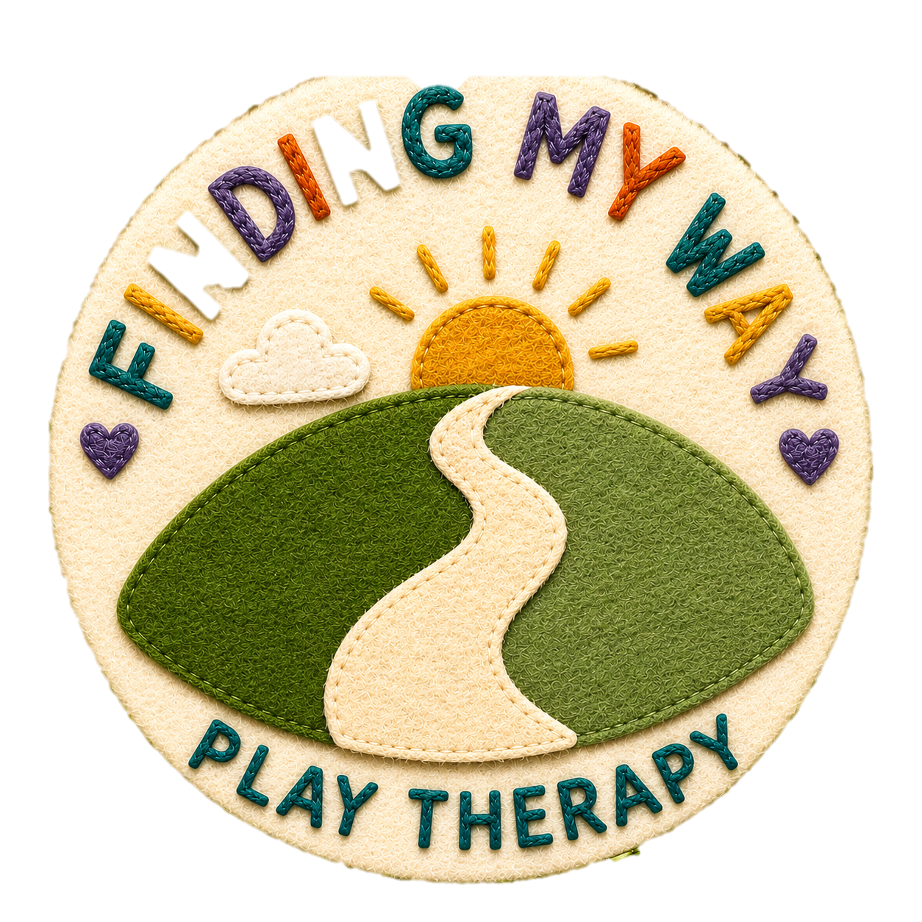
Therapeutic Contract for Play Therapy

Welcome
Welcome to Finding My Way Play Therapy. This agreement explains how Play Therapy works, what you can expect from me as your child's therapist, and what I ask of you to help therapy be as effective as possible.
My name is Tessa Cope, Certified Play Therapist and a registered member of Play Therapy UK (PTUK), accredited by the Professional Standards Authority (PSA). My work is guided by the PTUK Ethical Framework and Code of Professional Practice.
Play Therapy

Following the Initial Parent Assessment, we have agreed to begin Play Therapy for:
Child's name: ______________________________________
Therapy will begin with an Introductory (Family) Session, followed by a minimum of 12 weekly Play Therapy sessions during term time. Around 20 sessions are generally recommended to allow time for the therapeutic relationship to develop and meaningful therapeutic work to take place. However, every child is different, and the number of sessions will be reviewed according to your child's individual needs.
Play Therapy provides a safe, accepting and confidential space where children can explore their emotions, relationships and experiences through play. I work using an Integrative Holistic Play Therapy approach, which is primarily child-led and may include creative, sensory and therapeutic activities appropriate to the child's needs.

Introductory (Family) Session
The Introductory Session gives your child an opportunity to meet me, become familiar with the playroom and explore the play materials.
Parents or carers are welcome to attend if this helps their child settle. Following this session, Play Therapy sessions are normally attended by the therapist and child only. If separation is difficult, we will work together to find a supportive approach, which may include a gradual transition.
Play Therapy should always feel like your child's choice. I will never force a child to participate and will work at their pace to build trust and a sense of safety.
Therapy Sessions
Each Play Therapy session lasts approximately 40 minutes and takes place on the same day and time each week wherever possible.
Some children may benefit from additional sessions. This will be discussed during a Parent Review Meeting if appropriate.
Wherever possible, therapy should end gradually over at least three planned sessions to provide your child with a positive ending.

Therapy Schedule:

Session | Date | Time | Venue
Introductory (Family) Session
Session 1
Session 2
Session 3
Session 4
Session 5
Session 6
Session 7
Session 8
Session 9
Session 10
Session 11
Session 12

Bath Area Play Project address: Odd Down Community Centre. Odins Road. Odd Down. Bath. BA2 2TL

Additional sessions, including planned ending sessions, will be agreed as therapy progresses.

Parent Reviews
Parent Reviews are an important part of the therapeutic process and provide an opportunity to reflect on your child's progress together. A review will usually take place around Session 7, with a further meeting towards the end of therapy. These meetings are charged separately. We may discuss your child's progress, significant changes at home, therapeutic themes and whether further sessions or additional support may be beneficial.
Parents and carers are welcome to contact me by email during therapy to share significant changes or events that may be relevant to their child's therapeutic work.
Arriving and Collecting Your Child
I will meet you and your child at the front entrance of Odd Down Community Centre, unless otherwise agreed, and accompany your child to the playroom. If your child would prefer you to walk with them, you are welcome to accompany them to the playroom door.
During the session, parents and carers are asked to remain nearby, either in the community centre's lounge/waiting area or in their car nearby. The lounge has a sofa and access to the kitchen, where you are welcome to make yourself a tea or coffee. Toilets are also available if needed.
Please keep your phone switched on and available in case you need to be contacted during your child's session.
At the end of the session, I will bring your child back to the agreed collection point. Please be ready to collect your child at the agreed time. If someone other than the usual parent or carer will be collecting your child, please let me know in advance.
Please allow your child to leave the session without asking them what they have played with or what they have talked about. Children often need time to process their experiences and may choose to share things with you in their own time. I will provide appropriate feedback during Parent Review Meetings or contact you if there is anything important that needs to be discussed.
If your child wishes to end their session early, I will contact you by phone and agree arrangements for collecting them.
Please refer to the Play Therapy Room Risk Assessment, available on my website, for further information about safety and procedures.
Fees and Payment
The fees for Play Therapy are as follows:
- Play Therapy Session (40 minutes): £60
- Initial Parent Assessment (40–60 minutes): £45
- Parent Review Meeting (40–60 minutes): £45
- Final Report (optional): £55
Play Therapy sessions are invoiced monthly in arrears. An invoice will be provided at the end of each month for the sessions and other agreed services that are chargeable during that month.
Payment is due by the date stated on the invoice. If payment is not received by the due date, I will contact you to arrange payment. If an account remains unpaid, further sessions may need to be paused until the outstanding balance has been settled.
Attendance, Late Arrival and Cancellation
Sessions begin and end at the agreed time. If you arrive late, the session will normally finish at the scheduled time.
If your child is unable to attend, please give at least 24 hours’ notice. Sessions cancelled with less than 24 hours’ notice will be charged at the full session fee. Regular attendance is an important part of Play Therapy and helps provide the consistency and security children need to make the most of their sessions. If there are frequent cancellations or changes to attendance, we may have a conversation about whether the timing of therapy is working well for your child.
If your child chooses not to enter the therapy room or leaves a session early, the full session fee will still apply. This will be explored sensitively, as reluctance to engage can be part of a child’s therapeutic communication. If this happens on three occasions, we will review together whether your child is currently ready to engage in therapy and whether sessions should continue, pause or end.
If I need to cancel due to illness or exceptional circumstances, I will provide as much notice as possible and offer an alternative appointment wherever I can.
General Data Protection (GDPR)
Finding My Way Play Therapy handles personal information in accordance with data protection requirements. Information is collected and stored securely for the purpose of providing therapeutic services.
Further information about how your information is collected, stored and used is available in my GDPR/Privacy Policy, available on request and via my website.
Confidentiality and Safeguarding
Confidentiality is an important part of Play Therapy and helps children feel safe enough to express themselves through their play.
Parents and carers will receive updates about general progress, therapeutic themes and recommendations, but not detailed accounts of individual sessions unless the child chooses to share these.
Confidentiality may be broken where there is concern that a child or another person is at risk of significant harm, disclosure is required by law, or information needs to be discussed within professional Clinical Supervision.
I attend regular Clinical Supervision, where your child's work may be discussed anonymously using their first name.
Please also refer to the Finding My Way Play Therapy Safeguarding Children Policy.

Questions or Complaints
If you have any questions or concerns, please contact me in the first instance and I will do my best to resolve them.
Email:
tessacopeplaytherapy@gmail.com
If you remain dissatisfied, you may contact:
Play Therapy UK (PTUK), which operates an independent complaints procedure.
Please also refer to the Complaints Policy available on my website.

Agreement
I confirm that I have read and understood this Therapeutic Contract and agree to the arrangements described above.
Parent/Carer Name: ______________________________________
Signature: ______________________________________________
Date: _________________________________________________

